Jay Mahapatra

Lab 9- Can we use algorithms and compute to identify clothing items?

IST 718- Big Data Analysis

3/7/2019

**Goal:**

* Understand how neural networks work, how to run them, how accurate they are, and the trade-offs of using them. This will be done by grabbing the MNIST Fashion dataset, running the train and test data through two models (Keras and MLP) to identify images of different clothing items, and then compare the accuracy and time it takes to run each model when trying to identify images of clothing items.

**Hypothesis:**

* In comparing the MLP neural network to the Keras, Keras is also a neural network run through a tensor flow set up with slightly different parameters for the convolution and pooling layers compared to the in class neural net MLP. Thus, to compare the in class MLP to Keras, I will run the in class MLP on my computer and run the Keras MLP on Colab using GPU. I suspect the accuracy of the results will be skewed towards the Keras neural net as the parameters seem a little more advanced. In addition, Keras will be using a larger amount of computing power to get the results.

**Summary Statistics:**

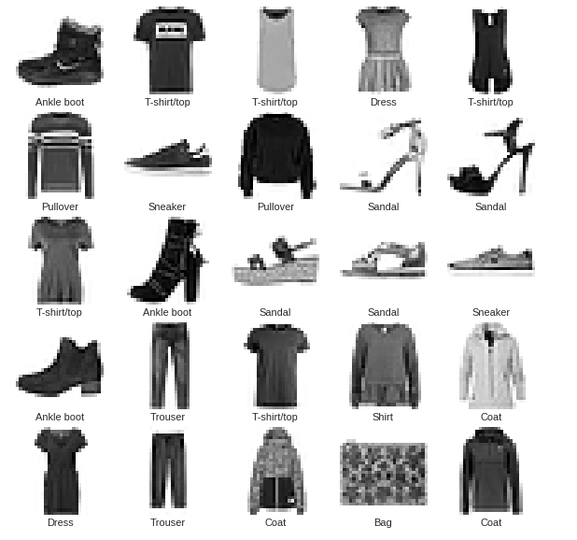

* The picture above represents examples of 9 types of clothing items (variables) the neural nets will be trying to identify from the MNIST Fashion data set.
* The full 9 items include:
  + T-shirt/top
  + Trouser
  + Pullover
  + Dress
  + Coat
  + Sandal
  + Shirt
  + Sneaker
  + Bag
  + Ankle boot

**Questions:**

***What is the accuracy of each method?***

|  |  |  |
| --- | --- | --- |
| Models | Train Accuracy | Test Accuracy |
| MLP (CPU) (1500 Epochs) | 85.23% | 82.88% |
| Keras (GPU) (25 Epochs) | 95.56% | 89.04% |

* As suspected, the Keras neural network had a higher accuracy overall on the train and test data set compared to the regular MLP neural network.
* However, what is also interesting is that there was a larger drop-off between the train test set in the Keras model than in the regular MLP model. This suggest that the variation of clothing items in both the train and test dataset for the MLP was higher than the variation in clothing items between the train and test set for the Keras model.

*Keras plot the first 15 test images, their predicted label, and the true label*

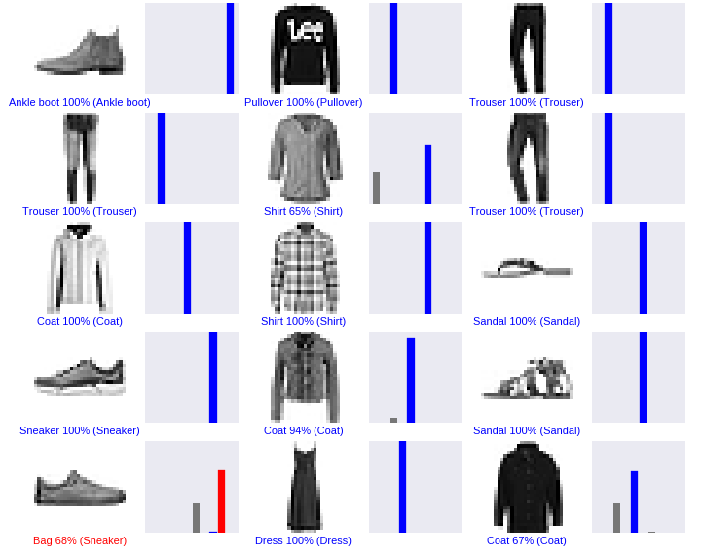

* As the plot shows, there may have not been enough examples of sneakers and coats in the train set because the model had trouble identifying these clothing items in the test set.

***What are the trade-offs of each approach?***

* MLP
  + **Positives**- Although a MLP neural network in general is somewhat complex, the parameters of the network are still relatively straight forward and easy to tune. In addition, it is easy to get a good estimate of accuracy vs. run time quickly.
  + **Negatives**- It was difficult to get the data into a data frame that the model could read, however, I think that has more to do with my ability to understand the file structure. In addition, the run time and number of epochs needed to correctly get a high accuracy was much longer than Keras as well as the accuracy was lower.
* Keras
  + **Positives**- Extremely simple to use, much faster computer processing time, and better accuracy then the MLP model. I would consider it the 2.0 version of the MLP neural network.
  + **Negatives**- It was slightly harder to judge computing compute performance and judge what was the correct number of epochs. I kept increasing the epochs by 5 until I saw that accuracy essentially trailed off. This was still substantially fewer epochs than the MLP neural net.

***What is the compute performance of each approach?***

* MLP

*MLP Plot for each of the 50 Batch Runs*

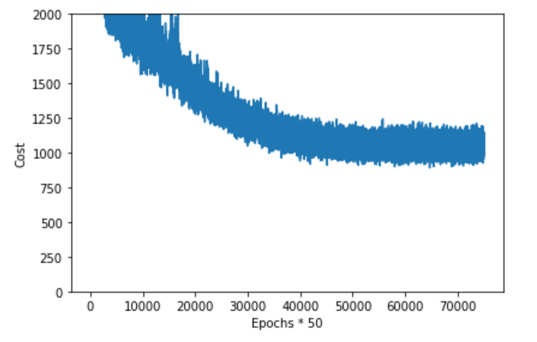

* + It took a little over 3,000 epochs to run final accuracy.
  + In addition, it took about 1202 seconds or 20 minutes to run the neural network.
* Keras

*Training/Test Validation Accuracy and loss*

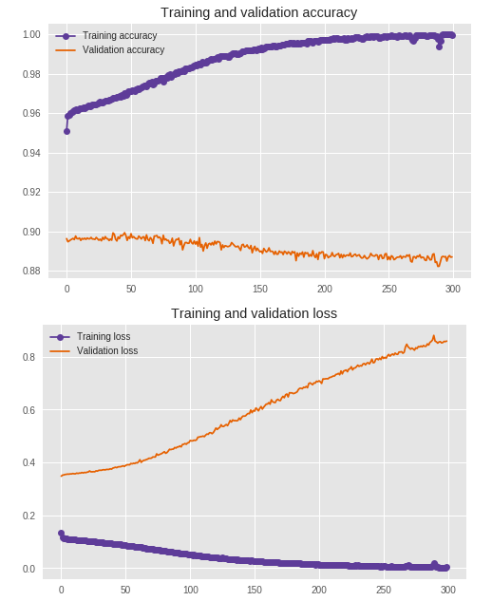

* + The Keras model took 6 minutes to run 25 epochs.
  + After about 25 epochs there seems to be an overfit in the accuracy in the training data compared to the test data suggesting the sets are not entirely distributed equally. Particularly around bags and sneakers.

**Next Steps/Conclusion:**

* The results concur with the hypothesis that the Keras model would perform slightly better than the class MLP model. In addition, it was interesting to see how much better Keras performed on accuracy and compute performance.
* As next steps I would like to test some other models to see how they stack up against the neural networks. I suspect the Random Forrest model could predict as accurately for a simple task like the one above. If one of my peers did that model I would be interested in knowing the results.

**References:**

* Pedro shared the link below which was immensely helpful
* <https://www.tensorflow.org/tutorials/keras/basic_classification>
* https://github.com/zalandoresearch/fashion-mnist